

Student Name: Timothy Spiteri

Student Number: 2460123

Module Code: 6CS007/MH1

Module Name: Project and Professionalism

Project Title: Designing and Evaluating a Transparent and Controllable Playlist Generation Pipeline Using Cross-Source Music Preference Data

Module Leader Name: Steven Camilleri

Supervisor Name: Thomas Xuereb

Reader Name: alex

Submission Date: 07/05/2026

Award Title: BSc (Hons) Computer Science

Declaration Sheet

Presented in partial fulfilment of the assessment requirements for the above award.

This work or any part thereof has not previously been presented in any form to the University or to any other institutional body whether for assessment or for other purposes. Save for any express acknowledgements, references and/or bibliographies cited in the work. I confirm that the intellectual contents of the work are the result of my own efforts and of no other person.

It is acknowledged that the author of any project work shall own the copyright.However, by submitting such copyright work for assessment, the author grants to the University a perpetual royalty-free licence to do all or any of those things referred to in section 16(i) of the Copyright Designs and Patents Act 1988.(viz: to copy work; to issue copies to the public; to perform or show or play the work in public; to broadcast the work or to make an adaptation of the work).

Student Name : Timothy Spiteri

Student Number: 2460123

Signature: 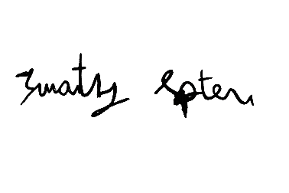Date: 08/05/2026

